Lesson 9: Florida Standards
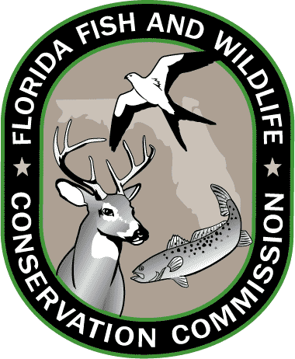
Grades 3-5

MATHEMATICS
MAFS.4.OA.3.5
Generate a number or shape pattern that follows a given rule. Identify apparent features of the pattern that were not explicit in the rule itself.

MAFS.4.OA.2.4
Investigate factors and multiples. Find all factor pairs for a whole number in the range 1–100. Recognize that a whole number is a multiple of each of its factors. Determine whether a given whole number in the range 1–100 is a multiple of a given one-digit number. Determine whether a given whole number in the range 1–100 is prime or composite

MAFS.5.G.1.2
Represent real world and mathematical problems by graphing points in the first quadrant of the coordinate plane, and interpret coordinate values of points in the context of the situation.

SCIENCE
SC.3.N.1.1
Raise questions about the natural world, investigate them individually and in teams through free exploration and systematic investigations, and generate appropriate explanations based on those explorations.

SC.4.N.2.1
Explain that science focuses solely on the natural world.

SOCIAL STUDIES
SS.3.A.1: Historical Inquiry and Analysis
Historical Inquiry and Analysis

SS.3.G.2.4: Environment and Society
Describe the climate and vegetation in the United States, Canada, Mexico, and the Caribbean.

SS.3.G.4.1: Human Systems
Explain how the environment influences settlement patterns in the United States, Canada, Mexico, and the Caribbean.

Grades 6-8

MATHEMATICS
MAFS.8.F.1.1
Understand that a function is a rule that assigns to each input exactly one output. The graph of a function is the set of ordered pairs consisting of an input and the corresponding output.

MAFS.8.SP.1.1
Construct and interpret scatter plots for bivariate measurement data to investigate patterns of association between two quantities. Describe patterns such as clustering, outliers, positive or negative association, linear association, and nonlinear association.

SCIENCE
SC.6.N.1.4
Discuss, compare, and negotiate methods used, results obtained, and explanations among groups of students conducting the same investigation.

SC.7.N.2.1
Identify an instance from the history of science in which scientific knowledge has changed when new evidence or new interpretations are encountered

SC.8.N.4.1
Explain that science is one of the processes that can be used to inform decision making at the community, state, national, and international levels.

SC.6.E.6.1
Describe and give examples of ways in which Earth's surface is built up and torn down by physical and chemical weathering, erosion, and deposition

SOCIAL STUDIES
SS.8.A.1
Use research and inquiry skills to analyze American History using primary and secondary sources.

SS.8.G.5
Understand how human actions can impact the environment.

SS.6.W.1
Utilize historical inquiry skills and analytical processes.

SS.8.C.2
Evaluate the roles, rights, and responsibilities of United States citizens, and determine methods of active participation in society, government, and the political system.

Resources: CPALMS.org and FLStandards.org; July 2014.

