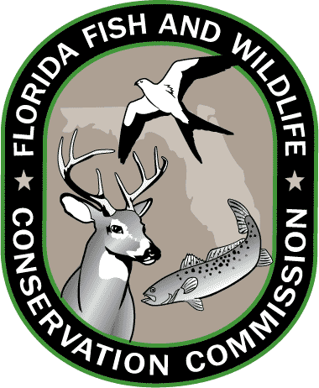
Lesson 8: Florida Standards

Grades 3-5

SCIENCE
SC.3.N.1.1
Raise questions about the natural world, investigate them individually and in teams through free exploration and systematic investigations, and generate appropriate explanations based on those explorations.

SC.4.N.2.1
Explain that science focuses solely on the natural world.

SC.4.L.17.1
Compare the seasonal changes in Florida plants and animals to those in other regions of the country.

LANGUAGE ARTS
LAFS.3.RF.3.3
Know and apply grade-level phonics and word analysis skills in decoding words.

LAFS.3.RI.4.10
By the end of the year, read and comprehend informational texts, including history/social studies, science, and technical texts, at the high end of the grades 2–3 text complexity band independently and proficiently

LAFS.5.SL.1.1
Engage effectively in a range of collaborative discussions (one-on-one, in groups, and teacher-led) with diverse partners on grade 5 topics and texts, building on others’ ideas and expressing their own clearly.

Grades 6-8

SCIENCE
SC.6.N.1.4
Discuss, compare, and negotiate methods used, results obtained, and explanations among groups of students conducting the same investigation.

SC.7.N.2.1
Identify an instance from the history of science in which scientific knowledge has changed when new evidence or new interpretations are encountered

SC.6.E.6.1
Describe and give examples of ways in which Earth's surface is built up and torn down by physical and chemical weathering, erosion, and deposition

SC.6.L.15.1
Analyze and describe how and why organisms are classified according to shared characteristics with emphasis on the Linnaean system combined with the concept of Domains.

SC.7.L.17.3
Describe and investigate various limiting factors in the local ecosystem and their impact on native populations, including food, shelter, water, space, disease, parasitism, predation, and nesting sites

SC.8.L.18.1
Describe and investigate the process of photosynthesis, such as the roles of light, carbon dioxide, water and chlorophyll; production of food; release of oxygen.

LANGUAGE ARTS
LAFS.6.L.3.6
Acquire and use accurately grade-appropriate general academic and domain-specific words and phrases; gather vocabulary knowledge when considering a word or phrase important to comprehension or expression.

LAFS.6.RI.4.10
By the end of the year, read and comprehend literary nonfiction in the grades 6–8 text complexity band proficiently, with scaffolding as needed at the high end of the range.

LAFS.8.SL.1.1
Engage effectively in a range of collaborative discussions (one-on-one, in groups, and teacher-led) with diverse partners on grade 8 topics, texts, and issues, building on others’ ideas and expressing their own clearly.

Resources: CPALMS.org and FLStandards.org; July 2014.

