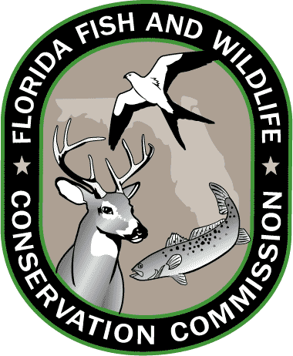
Lesson 6: Florida Standards

Grades 3-5

MATHEMATICS
MAFS.4.OA.3.5
Generate a number or shape pattern that follows a given rule. Identify apparent features of the pattern that were not explicit in the rule itself.

MAFS.5.MD.2.2
Make a line plot to display a data set of measurements in fractions of a unit (1/2, 1/4, 1/8). Use operations on fractions for this grade to solve problems involving information presented in line plots.

SCIENCE
SC.3.N.1.1
Raise questions about the natural world, investigate them individually and in teams through free exploration and systematic investigations, and generate appropriate explanations based on those explorations.

SC.4.N.2.1
Explain that science focuses solely on the natural world.

Grades 6-8

MATHEMATICS
MAFS.6.EE.1.2
Write, read, and evaluate expressions in which letters stand for numbers.

MAFS.7.SP.1.2
Use data from a random sample to draw inferences about a population with an unknown characteristic of interest. Generate multiple samples (or simulated samples) of the same size to gauge the variation in estimates or predictions.

MAFS.8.F.1.1
Understand that a function is a rule that assigns to each input exactly one output. The graph of a function is the set of ordered pairs consisting of an input and the corresponding output.

SCIENCE
SC.6.N.1.4
Discuss, compare, and negotiate methods used, results obtained, and explanations among groups of students conducting the same investigation.

SC.7.N.2.1
Identify an instance from the history of science in which scientific knowledge has changed when new evidence or new interpretations are encountered

SC.8.N.4.1
Explain that science is one of the processes that can be used to inform decision making at the community, state, national, and international levels.

SC.6.E.6.1
Describe and give examples of ways in which Earth's surface is built up and torn down by physical and chemical weathering, erosion, and deposition

Resources: CPALMS.org and FLStandards.org; July 2014.

