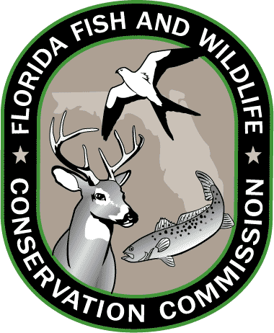
Lesson 5: Florida Standards

Grades 3-5

MATHEMATICS
MAFS.3.OA.1.3
Use multiplication and division within 100 to solve word problems in situations involving equal groups, arrays, and measurement quantities,

MAFS.4.OA.3.5
Generate a number or shape pattern that follows a given rule. Identify apparent features of the pattern that were not explicit in the rule itself.

MAFS.5.MD.2.2
Make a line plot to display a data set of measurements in fractions of a unit (1/2, 1/4, 1/8). Use operations on fractions for this grade to solve problems involving information presented in line plots.

SCIENCE
SC.3.N.1.1
Raise questions about the natural world, investigate them individually and in teams through free exploration and systematic investigations, and generate appropriate explanations based on those explorations.

SC.4.N.2.1
Explain that science focuses solely on the natural world.

SC.4.L.17.1
Compare the seasonal changes in Florida plants and animals to those in other regions of the country.

Grades 6-8

MATHEMATICS
MAFS.6.NS.1.1
Interpret and compute quotients of fractions, and solve word problems involving division of fractions by fractions, e.g., by using visual fraction models and equations to represent the problem.

MAFS.7.SP.1.2
Use data from a random sample to draw inferences about a population with an unknown characteristic of interest. Generate multiple samples (or simulated samples) of the same size to gauge the variation in estimates or predictions.

MAFS.8.F.1.1
Understand that a function is a rule that assigns to each input exactly one output. The graph of a function is the set of ordered pairs consisting of an input and the corresponding output.

SCIENCE
SC.6.N.1.4
Discuss, compare, and negotiate methods used, results obtained, and explanations among groups of students conducting the same investigation.

SC.7.N.2.1
Identify an instance from the history of science in which scientific knowledge has changed when new evidence or new interpretations are encountered

SC.6.E.6.1
Describe and give examples of ways in which Earth's surface is built up and torn down by physical and chemical weathering, erosion, and deposition

SC.8.L.18.4
Cite evidence that living systems follow the Laws of Conservation of Mass and Energy.

SC.6.L.15.1
Analyze and describe how and why organisms are classified according to shared characteristics with emphasis on the Linnaean system combined with the concept of Domains.

SC.7.L.16.1
Understand and explain that every organism requires a set of instructions that specifies its traits, which this hereditary information (DNA) contains genes located in the chromosomes of each cell, and that heredity is the passage of these instructions from one generation to another.

SC.7.L.17.3
Describe and investigate various limiting factors in the local ecosystem and their impact on native populations, including food, shelter, water, space, disease, parasitism, predation, and nesting sites

SC.8.L.18.1
Describe and investigate the process of photosynthesis, such as the roles of light, carbon dioxide, water and chlorophyll; production of food; release of oxygen.

Resources: CPALMS.org and FLStandards.org; July 2014.

