Lesson 3: Florida Standards
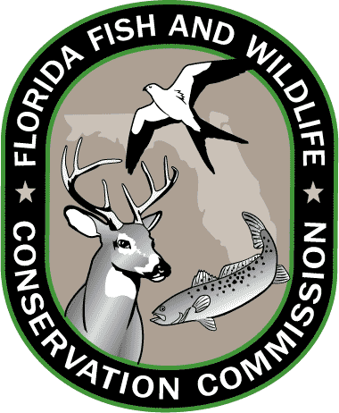
Grades 3-5

SOCIAL STUDIES
SS.3.G.2.4
Describe the climate and vegetation in the United States, Canada, Mexico, and the Caribbean.

SS.3.G.4.1
Explain how the environment influences settlement patterns in the United States, Canada, Mexico, and the Caribbean.

SS.3.C.1.3

Explain how government was established through a written Constitution.
SS.3.C.2.1
Identify group and individual actions of citizens that demonstrate civility, cooperation, volunteerism, and other civic virtues.

SS.4.A.2.1
Compare Native American tribes in Florida.

SS.4.A.4.1
Describe pioneer life in Florida.

SCIENCE
SC.3.N.1.1
Raise questions about the natural world, investigate them individually and in teams through free exploration and systematic investigations, and generate appropriate explanations based on those explorations.

SC.4.N.2.1
Explain that science focuses solely on the natural world.

Grades 6-8

SOCIAL STUDIES
SS.3.G.1.1
Use thematic maps, tables, charts, graphs, and photos to analyze geographic information.

SS.7.G.2
Understand how human actions can impact the environment.

SS.8.G.5
Understand how human actions can impact the environment.

SS.6.W.1
Utilize historical inquiry skills and analytical processes.

SS.8.C.2
Evaluate the roles, rights, and responsibilities of United States citizens, and determine methods of active participation in society, government, and the political system.

SCIENCE
SC.6.N.1.4
Discuss, compare, and negotiate methods used, results obtained, and explanations among groups of students conducting the same investigation.

SC.7.N.2.1
Identify an instance from the history of science in which scientific knowledge has changed when new evidence or new interpretations are encountered

SC.8.N.4.1
Explain that science is one of the processes that can be used to inform decision making at the community, state, national, and international levels.

SC.6.E.6.1
Describe and give examples of ways in which Earth's surface is built up and torn down by physical and chemical weathering, erosion, and deposition.

Resources: CPALMS.org and FLStandards.org; July 2014.

