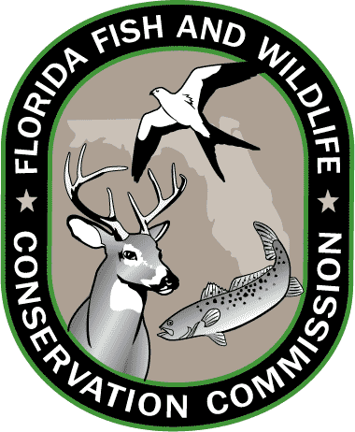
Lesson 2: Florida Standards

Grades 3-5

SOCIAL STUDIES
SS.3.G.1.1
Use thematic maps, tables, charts, graphs, and photos to analyze geographic information.

SCIENCE
SC.3.N.1.1
Raise questions about the natural world, investigate them individually and in teams through free exploration and systematic investigations, and generate appropriate explanations based on those explorations.

SC.4.N.2.1
Explain that science focuses solely on the natural world.

SC.5.L.17.1
Compare and contrast adaptations displayed by animals and plants that enable them to survive in different environments such as life cycles variations, animal behaviors and physical characteristics.

SC.4.L.17.1
Compare the seasonal changes in Florida plants and animals to those in other regions of the country.

LANGUAGE ARTS
LAFS.3.RI.4.10
By the end of the year, read and comprehend informational texts, including history/social studies, science, and technical texts, at the high end of the grades 2–3 text complexity band independently and proficiently.

LAFS.5.SL.1.1
Engage effectively in a range of collaborative discussions (one-on-one, in groups, and teacher-led) with diverse partners on grade 5 topics and texts, building on others’ ideas and expressing their own clearly.

MATHEMATICS
MAFS.4.OA.3.5
Generate a number or shape pattern that follows a given rule. Identify apparent features of the pattern that were not explicit in the rule itself.

MAFS.5.G.1.2
Represent real world and mathematical problems by graphing points in the first quadrant of the coordinate plane, and interpret coordinate values of points in the context of the situation.

Grades 6-8

SOCIAL STUDIES
SS.6.G.1.4
Utilize tools geographers use to study the world.

SS.7.G.2.1
Understand physical and cultural characteristics of places.

SCIENCE
SC.6.N.1.4
Discuss, compare, and negotiate methods used, results obtained, and explanations among groups of students conducting the same investigation.

SC.7.N.2.1
Identify an instance from the history of science in which scientific knowledge has changed when new evidence or new interpretations are encountered

SC.8.L.18.4
Cite evidence that living systems follow the Laws of Conservation of Mass and Energy.

SC.6.L.15.1
Analyze and describe how and why organisms are classified according to shared characteristics with emphasis on the Linnaean system combined with the concept of Domains.

SC.7.L.16.1
Understand and explain that every organism requires a set of instructions that specifies its traits, which this hereditary information (DNA) contains genes located in the chromosomes of each cell, and that heredity is the passage of these instructions from one generation to another.
SC.7.L.17.3
Describe and investigate various limiting factors in the local ecosystem and their impact on native populations, including food, shelter, water, space, disease, parasitism, predation, and nesting sites

SC.8.L.18.1
Describe and investigate the process of photosynthesis, such as the roles of light, carbon dioxide, water and chlorophyll; production of food; release of oxygen.

LANGUAGE ARTS
LAFS.6.L.3.6
Acquire and use accurately grade-appropriate general academic and domain-specific words and phrases; gather vocabulary knowledge when considering a word or phrase important to comprehension or expression.
LAFS.6.RI.4.10
By the end of the year, read and comprehend literary nonfiction in the grades 6–8 text complexity band proficiently, with scaffolding as needed at the high end of the range.

LAFS.8.SL.1.1
Engage effectively in a range of collaborative discussions (one-on-one, in groups, and teacher-led) with diverse partners on grade 8 topics, texts, and issues, building on others’ ideas and expressing their own clearly.

MATHEMATICS
MAFS.7.SP.1.2
Use data from a random sample to draw inferences about a population with an unknown characteristic of interest. Generate multiple samples (or simulated samples) of the same size to gauge the variation in estimates or predictions.

MAFS.8.SP.1.1
Construct and interpret scatter plots for bivariate measurement data to investigate patterns of association between two quantities. Describe patterns such as clustering, outliers, positive or negative association, linear association, and nonlinear association.

Resources: CPALMS.org and FLStandards.org; July 2014.

