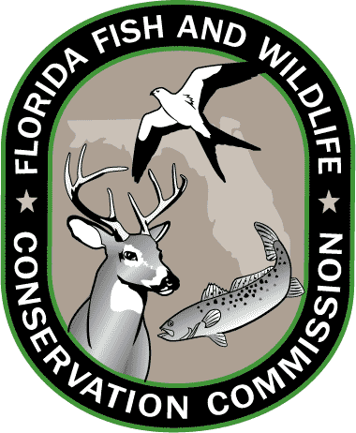
Lesson 10: Florida Standards

Grades 3-5

SOCIAL STUDIES
SS.3.A.1: Historical Inquiry and Analysis
Historical Inquiry and Analysis.

SS.3.G.1.1: The World in Spatial Terms
Use thematic maps, tables, charts, graphs, and photos to analyze geographic information.

SS.3.G.2.4: Environment and Society
Describe the climate and vegetation in the United States, Canada, Mexico, and the Caribbean.

SS.3.G.4.1: Human Systems
Explain how the environment influences settlement patterns in the United States, Canada, Mexico, and the Caribbean.

LANGUAGE ARTS
LAFS.3.RI.4.10
By the end of the year, read and comprehend informational texts, including history/social studies, science, and technical texts, at the high end of the grades 2–3 text complexity band independently and proficiently

LAFS.4.W.32.4
Produce clear and coherent writing in which the development and organization are appropriate to task, purpose, and audience.

LAFS.5.SL.1.1
Engage effectively in a range of collaborative discussions (one-on-one, in groups, and teacher-led) with diverse partners on grade 5 topics and texts, building on others’ ideas and expressing their own clearly.

SCIENCE
SC.3.N.1.1
Raise questions about the natural world, investigate them individually and in teams through free exploration and systematic investigations, and generate appropriate explanations based on those explorations.

SC.4.N.2.1
Explain that science focuses solely on the natural world.

MATHEMATICS
MAFS.5.G.1
Graph points on the coordinate plane to solve real-world and mathematical problems

Grades 6-8

SOCIAL STUDIES
SS.8.A.1
Use research and inquiry skills to analyze American History using primary and secondary sources.

SS.6.G.1.4
Utilize tools geographers use to study the world.

SS.7.G.2
Understand how human actions can impact the environment.

SS.8.G.5
Understand how human actions can impact the environment.

SS.6.W.1
Utilize historical inquiry skills and analytical processes.

LANGUAGE ARTS
LAFS.6.RI.4.10
By the end of the year, read and comprehend literary nonfiction in the grades 6–8 text complexity band proficiently, with scaffolding as needed at the high end of the range.

LAFS.8.W.1.2
Write informative/explanatory texts to examine a topic and convey ideas, concepts, and information through the selection, organization, and analysis of relevant content.

SCIENCE
SC.6.N.1.4
Discuss, compare, and negotiate methods used, results obtained, and explanations among groups of students conducting the same investigation.

SC.7.N.2.1
Identify an instance from the history of science in which scientific knowledge has changed when new evidence or new interpretations are encountered.

Resources: CPALMS.org and FLStandards.org; July 2014.

