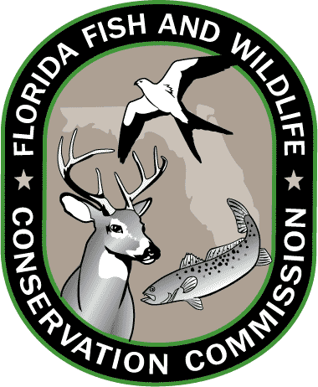
Lesson 1: Florida Standards

Grades 3-5

SCIENCE
SC.3.N.1.1
Raise questions about the natural world, investigate them individually and in teams through free exploration and systematic investigations, and generate appropriate explanations based on those explorations.
SC.4.N.2.1
Explain that science focuses solely on the natural world.

SC.5.L.17.1
Compare and contrast adaptations displayed by animals and plants that enable them to survive in different environments such as life cycles variations, animal behaviors and physical characteristics.

LANGUAGE ARTS
LAFS.3.RI.4.10
By the end of the year, read and comprehend informational texts, including history/social studies, science, and technical texts, at the high end of the grades 2–3 text complexity band independently and proficiently.

LAFS.4.W.32.4
Produce clear and coherent writing in which the development and organization are appropriate to task, purpose, and audience.

LAFS.5.SL.1.1
Engage effectively in a range of collaborative discussions (one-on-one, in groups, and teacher-led) with diverse partners on grade 5 topics and texts, building on others’ ideas and expressing their own clearly.

Grades 6-8

SCIENCE
SC.6.N.1.4
Discuss, compare, and negotiate methods used, results obtained, and explanations among groups of students conducting the same investigation.

SC.7.N.2.1
Identify an instance from the history of science in which scientific knowledge has changed when new evidence or new interpretations are encountered

SC.8.L.18.4
Cite evidence that living systems follow the Laws of Conservation of Mass and Energy.

LANGUAGE ARTS
LAFS.6.RI.4.10
By the end of the year, read and comprehend literary nonfiction in the grades 6–8 text complexity band proficiently, with scaffolding as needed at the high end of the range.

LAFS.7.W.1.2
Write informative/explanatory texts to examine a topic and convey ideas, concepts, and information through the selection, organization, and analysis of relevant content.

LAFS.8.SL.1.1
Engage effectively in a range of collaborative discussions (one-on-one, in groups, and teacher-led) with diverse partners on grade 8 topics, texts, and issues, building on others’ ideas and expressing their own clearly.

Resources: CPALMS.org and FLStandards.org; July 2014.

